|  |  |
| --- | --- |
| **Homework #1**  *Digital Image Processing(EEE5320), 2019-2* | Due Date: 2019. 09.30 |

1. Intensity Transformations (60pt)

 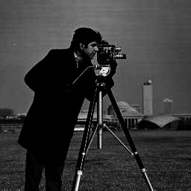

**Figure 1. input1 Figure 2. Input2**

* 1. Piecewise Linear Transformation (20pt)

1. Transform ‘input1.jpg’ image using piecewise linear functions. Complete the remaining part of provided PiecewiseLinearTr.m function and run hw1_1.m file

|  |
| --- |
| function output = PiecewiseLinearTr(input,a,b) %  % PiecewiseLinearTr(IM,A,B) applies a piecewise linear transformation to the pixel values  % of the input image INPUT, where A and B are vectors containing the x and y coordinates  % of the ends of the line segments. INPUT can be of type DOUBLE,  % and the values in A and B must be between 0 and 1 (normalized intensity values). %  % For example:  %  % PiecewiseLinearTr(x,[0,1],[1,0])  %  % simply do negative transform inverting the pixel values.  %    if length(a) ~= length (b)  error('Vectors A and B must be of equal size');  end    ***% Complete the remaining part***  % set output size equal to input size  output= zeros(size(input));  % iterate for every vector  for i = 1:length(a)-1  % set vector  a1 = a(i);  a2 = a(i+1);  b1 = b(i);  b2 = b(i+1);    % mask image  filter = (input >= a1) & (input <= a2);    % transformation  % Equation: s = ((b2-b1)/(a2-a1))(r-a1) + b1  m = (b2-b1)/(a2-a1);  % merge output  output = output + filter.*(m*(input-a1) + b1);  end |
| **[PiecewiseLinearTr.m]** |

|  |
| --- |
| im = im2double(imread(input1.jpg'));    im_Tr = PiecewiseLinearTr(im, [0,1], [1,0]);  im_Tr2 = PiecewiseLinearTr(im, [0 .25 .5 .75 1],[0 .75 .25 .5 1]);    figure(1);  x_axis = [0:1/255:1];  subplot(1,2,1);  plot(x_axis, PiecewiseLinearTr(x_axis, [0,1], [1,0]));  subplot(1,2,2);  plot(x_axis, PiecewiseLinearTr(x_axis, [0 .25 .5 .75 1],[0 .75 .25 .5 1]));    figure(2);  subplot(1,2,1);  imshow(im_Tr);  subplot(1,2,2);  imshow(im_Tr2);    figure(3);  subplot(1,2,1);  imhist(im_Tr);  subplot(1,2,2);  imhist(im_Tr2); |
| **[hw1_1.m]** |

1. Plot the two transformation functions.

1. Display the histograms of the output images and the output images itself.

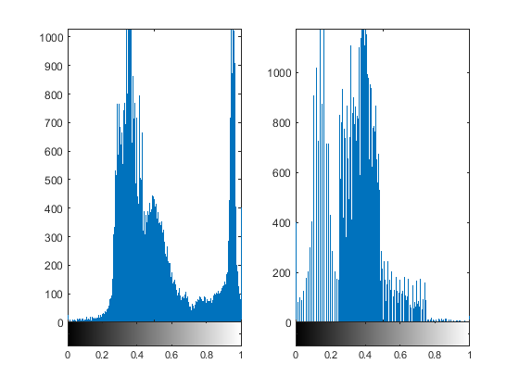

1. Explain your implementation and discuss your results.

[Explain Implementation]

1. Define vectors for transfer functions

2. Determine which part of the image corresponds to the area to be converted.

3. Convert the intensity value using the transfer function for the corresponding part

4. Merge converted images and make output

5. Plot histogram and output image

[Discussion]

The output histogram of negative transformation confirmed that the left and right parts of the histogram of the input image were converted in reverse value. The output image also shows that the intensity value of the input image was reversed and that the figure in black was converted to white.

The output histogram of piecewise linear transformation shows that the brightness portion of the input image has changed to match the shape of a given linear transfer function. In the transfer function, a portion with a rapidly changing intensity was 0.25 to 0.5. This is expressed as noise in the output image, which corresponds to the edge of the target.

* 1. Sigmoid Transformation (20pt)

1. Transform ‘input1.png’ using sigmoid transformation $σ(x)$ = $\frac{1}{1+e^{-γ(x-0.5)}}$ for $γ$ = [5, 10, 20, 40] (a range of x is from 0 to 1).

|  |
| --- |
| function output = SigmoidTr(input, gamma)  % Returns transformed image by sigmoid transformation with gamma where INPUT is a gray scale input image  ***% Complete the remaining part***  % transformation  output = 1 ./ (1 + exp(-1 .* gamma .* (input-0.5))); |
| **[SigmoidTr.m]** |

|  |
| --- |
| im = im2double(imread('input1.png'));    gamma = [5, 10, 20, 40];    figure(1);  for i = 1:length(gamma)  hold on;  x_axis = [0:1/255:1];  f_Tr = SigmoidTr(x_axis, gamma(i));  plot(x_axis, f_Tr);  legend({'\gamma = 5', '\gamma = 10', '\gamma = 20', '\gamma = 40'}, 'Location','northwest');  end    figure(2);  for i = 1:length(gamma)  im_Tr = SigmoidTr(im, gamma(i));  subplot(2,2,i);  imshow(im_Tr);  title(['\gamma = ',num2str(gamma(i))]);  end |
| **[hw1_2.m]** |

1. Plot the transformation functions.

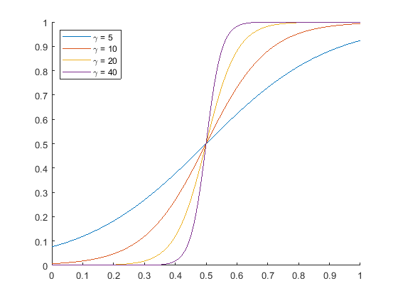

1. Display the histograms of the output images and the output images itself.

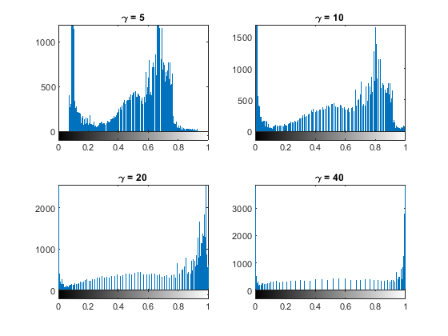

1. Explain your implementation and discuss your results.

[Explain implementation]

1. Define the transfer function corresponding to given sigmoid function in the task
2. Plot transfer function to check gradients changing with gamma value

[Discussion]

As found in the histogram of the output image, Higher gamma value increases intensity of the image parts corresponding to small and high intensity. The value of the part corresponding to the brightness of the middle part decreases, resulting in greater contrast to the image.

* 1. Power Law Transformation (20pt)

1. Transform ‘input2.png’ using power law transformations for $γ$ = [0.2, 0.4, 2.5, 5].

|  |
| --- |
| function output = PowerLawTr(input, gamma)  % Returns transformed image by power law transformation with gamma where INPUT is a gray scale input image  ***% Complete the remaining part***  % transformation  output= input.^(gamma); |
| **[PowerLawTr.m]** |

|  |
| --- |
| im = im2double(imread('input2.png'));    gamma = [0.2, 0.4, 2.5, 5];    figure(1);  for i = 1:length(gamma)  hold on;  x_axis = [0:1/255:1];  f_Tr = PowerLawTr(x_axis, gamma(i));  plot(x_axis, f_Tr);  legend({'\gamma = 0.2', '\gamma = 0.4', '\gamma = 2.5', '\gamma = 5'}, 'Location','northwest');  end    figure(2);  for i = 1:length(gamma)  im_Tr = PowerLawTr(im, gamma(i));  subplot(2,2,i);  imshow(im_Tr);  title(['\gamma = ',num2str(gamma(i))]);  end |
| **[hw1_3.m]** |

1. Plot the transformation functions.

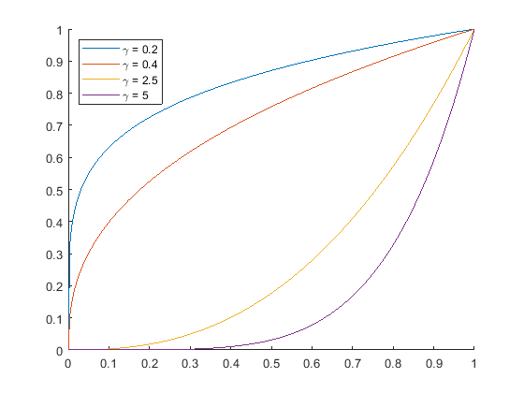

1. Display the histograms of the output images and the output images itself.

1. Explain your implementation and discuss your results.

[Explain implementation]

1. Define conversion functions by square gamma at the brightness of the input function
2. Plot transfer function to check gradients changing with gamma value

[Discussion]

As can be seen in the histogram, the lower the gamma value, the higher the value of the brighter part. This means that the image is brightened and can be seen on the converted output image.

1. Histogram Equalization (40pt)

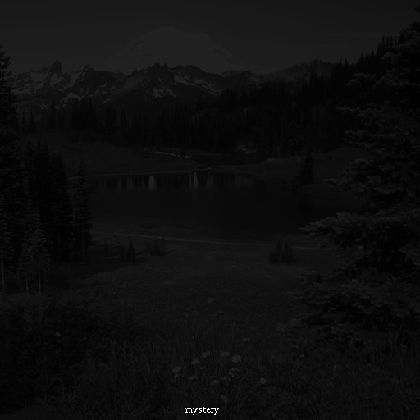

**Figure 3. input3**

* 1. Load the attatched “input3.jpg” and display the histogram of the image.

|  |
| --- |
| %2-1 Load image and Display histogram  % load image  im = im2double(imread('input3.png'));  % fig 1: histogram of the input image  figure(1);  imhist(im);  title(['2-1. Histogram of Input Image']); |
| **[HW2.m]** |

* 1. Implement a Matlab function for histogram equalization.

**(You should not use ‘histeq’ built-in function)**

|  |
| --- |
| %2-2 implement histogram equalization function;    % image size  size_im = size(im);  MN = size_im(1) * size_im(2);  % make 256bins of histogram  hist = imhist(im,256);  L = length(hist);  % calculate pdf,cdf  pdf = hist ./ MN;  cdf = cumsum(pdf);  % histogram equalized array  s_arr = round((L-1).*cdf);  % map input image to histogram-equalized image  output = zeros(size(im));  for i = 1:L  mask = (im >= (i-1)/L) & (im <= i/L);  output = output + mask .* (s_arr(i)/L);  end    % fig 2: histogram of the output image  figure(2);  imhist(output);  title(['2-2. Histogram of Output Image']);  % fig 3: Output image  figure(3);  imshow(output);  title(['2-3. Output Image']); |
| **[HW2.m]** |

* 1. Display the histogram of the input image created in step 3 and the output image itself.

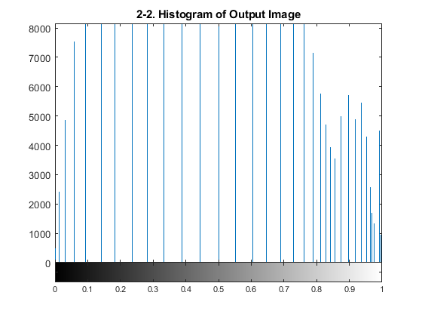

* 1. Explain your implementation and discuss your results

[Explain implementation]

1. Calculate the histogram of the input image.

- Since the input image is black and white, I used 256 brightness levels, which are the default for the MATLAB.

2. To obtain the PDF of the input image, the value of the histogram is divided by the total number of pixels

3. Obtain CDF by integrating PDF function

4. Histogram-Equalized s-array could be obtained by rounding up CDF

5. Map the area of the image corresponding to the intensity level with s- array.

[Discussion]

Based on the histogram, values that were centered on lower values of 0.1 or less are distributed evenly between intensity level 0-1. As a result, the distribution of the intensity level of the image has been evenly distributed, and the view that was not well seen in the input image is visible in the output image.

1. Histogram Matching (40pt)

 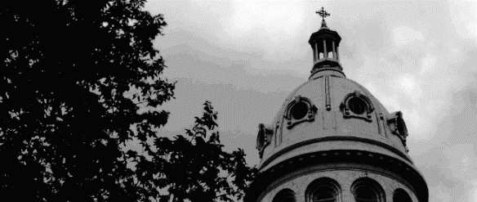

Figure 4. input4 Figure 5. Input4_match

* 1. Implement a Matlab function for histogram matching to produce an image that looks like the provided image ‘input4_match.jpg’.

**(You should not use ‘imhistmatch’ built-in function)**

|  |
| --- |
| %3-1 Load images  % load image  im = im2double(imread('input4.png'));  im_match = im2double(imread('input4_match.png'));    %3-2 Display histogram  % fig 1: histogram of the input image  figure(1);  imhist(im);  title(['3-2-1. Histogram of Input Image']);  % fig 1: histogram of the input image  figure(2);  imhist(im_match);  title(['3-2-2. Histogram of the Matching Image']);    %2-2 implement histogram matching function;  % image size  size_im = size(im);  MN = size_im(1) * size_im(2);  % make 256bins of histogram  L = 256;  hist = imhist(im,L);  hist_match = imhist(im_match,L);    % calculate pdf  pdf = hist ./ MN;  pdf_match = hist_match ./ MN;  % calculate transformation function  s_k = round((L-1).*cumsum(pdf));  G_zq = round((L-1).*cumsum(pdf_match));    % map input image to histogram-equalized image  output = zeros(size(im));  for i = 1:L  % select from input image  mask = (im >= (i-1)/L) & (im <= i/L);  % apply 1st transfer function  T_rk = s_k(i);  % find closest distance from G(zq)  dist = abs(G_zq-T_rk);  [val_dist,idx_dist] = min(dist);  % apply 2nd transfer function  T_sk = idx_dist;  % merge output  output = output + mask .* (T_sk/L);  end    % fig 3: histogram of the output image  figure(3);  imhist(output);  title(['3-3-1. Histogram of Output Image']);  % fig 4: Output image  figure(4);  imshow(output);  title(['3-3-2. Output Image']); |
| **[HW3.m]** |

* 1. Display the histogram of the images : ‘input4.jpg’, ‘input4_match.jpg’.

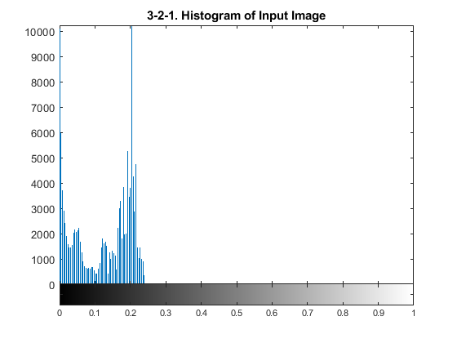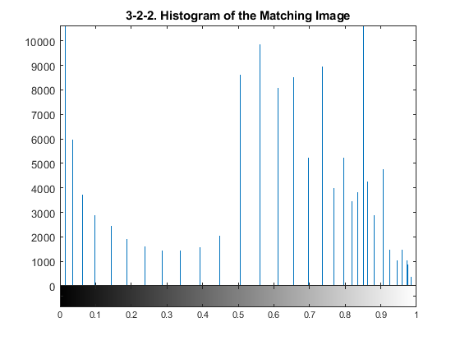

* 1. Display the histogram of the output image and the output image itself.

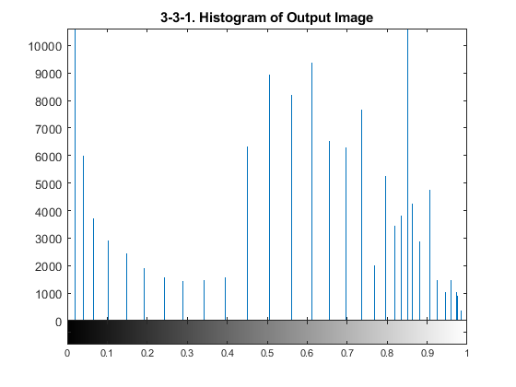

* 1. Explain your implementation and discuss your results

[Explain Implementation]

1. Calculate the histogram of the input image.

- Since the input image is black and white, I used 256 brightness levels, which are the default for the MATLAB.

2. To obtain the PDF of the input and histogram-matched image, the value of the histogram is divided by the total number of pixels

3. Integrate and round PDF functions to obtain transfer function S(k) and G(zq)

4. Map the area of the image corresponding to the intensity level to the value closest to the value of S(k) in G(zq)

[Discussion]

The intensity value, which was less than or equal to 0.2 in the input image, was distributed as in the matching image. As can be seen in the output image, intensity of the output image has been converted to a similar to the match image.